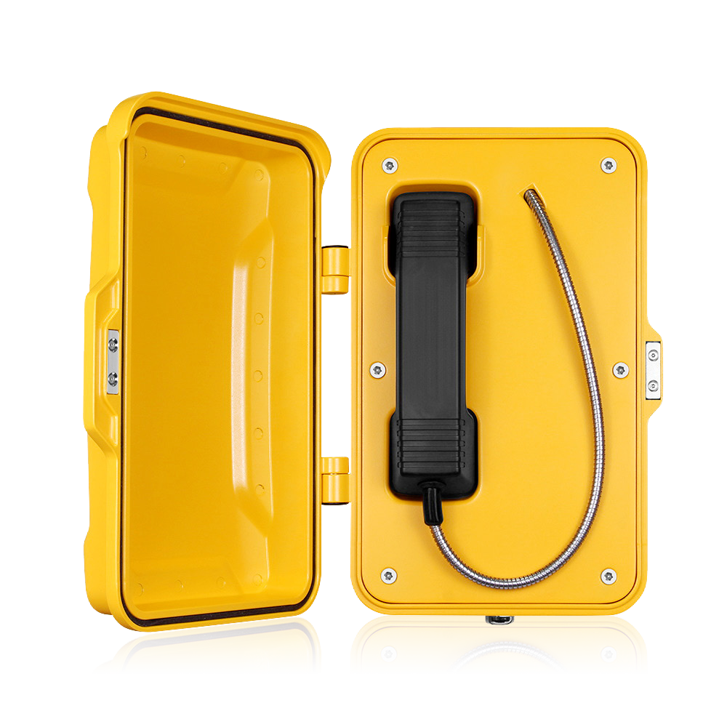

JR101-CB-4G

* **Aluminum alloy die-casting body**
* **Protection level IP66/IP67**
* **Advanced noise reduction technology for HD calls**
* **Corrosion-resistant hardware**
* **CE, FCC, RoHS, IK10, IP67, ISO9001 standards**

**IP67**

**IK10**

**HD**

**Waterproof Telephone**

# MAIN FEATURES

It was designed for public and industrial areas requiring a virtually indestructible telephone. The housing is made of die-cast aluminum alloy, with a weatherproof enclosure and an exterior polyurethane finish. It is designed to withstand high levels of humidity, dust, vibration, shock, extreme temperatures, (salt)water, abuse or attempted vandalism.

Typical applications include Outdoor Environments, Public Highways, Underground Tunnels / Mining, Offshore Wind Farms, Production Floors, Chemical Processing Sites, Power Stations or inside large Lifting Machinery such as Quayside Container Cranes, Rubber-Tyred Gantry Cranes (RTGs) and bulk-material Ship Loaders.

* Hotline telephone without keypad
* 4G wireless communication with remote configuration
* Handset with noise-cancelling microphone and 42 cm armored cord (optional heavy duty curly cord)
* The handset supports hearing aid compatibility (HAC)
* Magnetic reed hook switch to reduce wear-prone parts
* With door cover, supports wall mounting with mounting bar
* Wiring access, 3xM20 cable gland entry points

# TECHNICAL SPECIFICATIONS

|  |  |
| --- | --- |
| **4G Specifications** | |
| Power supply | 12V DC |
| Adapter input | 7.4 V-12V DC |
| Power consumption | Idle 0.3W / Working 1.5W |
| Communication mode | 4G |
| Working frequency | Depends on modules |
| Ringing tone | 90 dB (A) @ 1 meter |
| Configuration method | Remote configuration via SMS, allows management from a central location |
| Configuration | Remote monitoring / Auto-dial numbers |
| Time out | Enforces a fixed call maximum time limit of 6-8 minutes from off-hook, configurably |
| Diagnostic function | Low battery voltage, weak signal, speaker volume, microphone volume can be reported via message |
| Antenna | Quad-band SMA male, externally mounted with 2 m cable |
| Environment temperature | Operating temperature -40˚C to 65˚C; Storage temperature -40°C to 75°C |
| M.T.B.F. | Exceeds 50,000 hours under normal operating conditions |

|  |  |  |  |  |  |
| --- | --- | --- | --- | --- | --- |
| **4G Module EC25** | | | | | |
| **Module** | **EC25-E** | **EC25-EU / EUX** | **EC25-J** | **EC25-V** | |
| **Region** | EMEA/Korea/Thailand/India | EMEA/Thailand | Japanese | America Verizon | |
| **Frequency** |  | | | | |
| LTE-FDD | B1/B3/B5/B7/B8/B20 | B1/B3/B7/B8/B20/B28A | B1/B3/B8/B18/B19/B26 | B4/B13 | |
| LTE-TDD | B38/B40/B41 | B38/B40/B41 | B41 | / | |
| WCDMA | B38/B40/B41 | B1/B8 | B1/B6/B8/B19 | / | |
| GSM/EDGE | B3/B8 | B3/B8 | / | / | |
| GNSS | GPS/GLONASS/BeiDou (Compass)/  Galileo/QZSS (option) | GPS/GLONASS/BeiDou (Compass)/  Galileo/QZSS (option) | GPS/GLONASS/BeiDou (Compass)/  Galileo/QZSS (option) | GPS/GLONASS/BeiDou (Compass)/  Galileo/QZSS (option) | |
| **Module** | **EC25-A** | **EC25-AF / AFX / AFXD (Data-only)** | **EC25-AUX** | | **EC25-MX** |
| **Region** | North America | North America | Latin America/Australia/New Zealand | | Mexico |
| **Frequency** |  | | | | |
| LTE-FDD | B2/B4/B12 | B2/B4/B5/B12/B13/B14/B66/B71 | B1/ B2/B3/B4/B5/B7/B8/B28 | | B2/B4/B5/B7/B28/B66 |
| LTE-TDD | / | / | B40 | | / |
| WCDMA | B2/B4/B5 | B2/B4/B5 | B1/B2/B4/B5/B8 | | B2/B4/B5 |
| GSM/EDGE | / | / | B2/B3/B5/B8 | | / |
| GNSS | GPS/GLONASS/BeiDou (Compass)/  Galileo/QZSS (option) | GPS/GLONASS/BeiDou (Compass)/  Galileo/QZSS (option) | GPS/GLONASS/BeiDou (Compass)/  Galileo/QZSS (option) | | / |

**APPLICATIONS**

Insert the SIM card into the 4G phone and connect to the operator's network to make calls

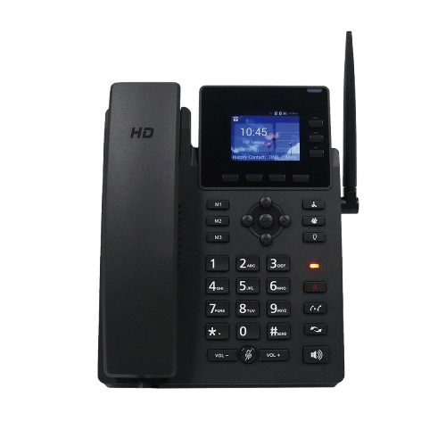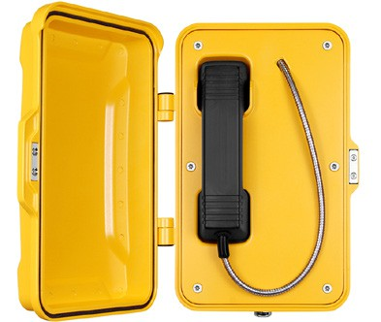

Cell phone

Cloud

Signal from the base station tower

4G Desk Telephone

Cell phone

**...**

JR101-CB-4G

JR101-CB-4G

JR101-CB-4G

JR101-CB-4G

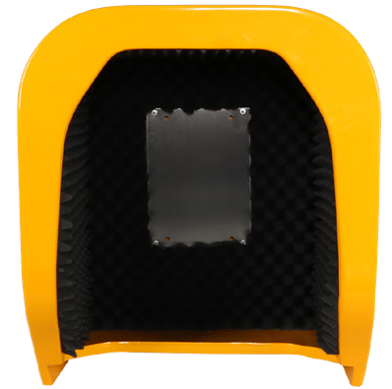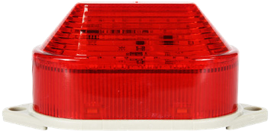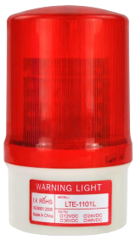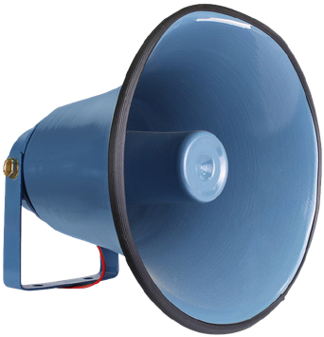

**OPTIONAL ACCESSORIES**

JR-LP-01

LED Light

JR-LP-02

LED Beacon Light

JR-HSA-10/20/25/30/35

Broadcast Horn

JR-TH-01

Acoustic Hood

# APPLICATION SCENARIOS

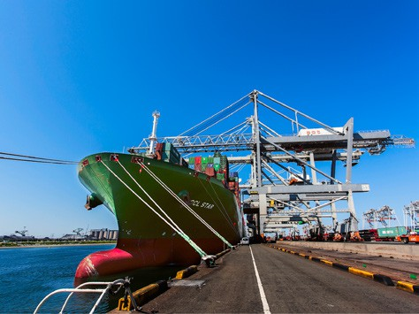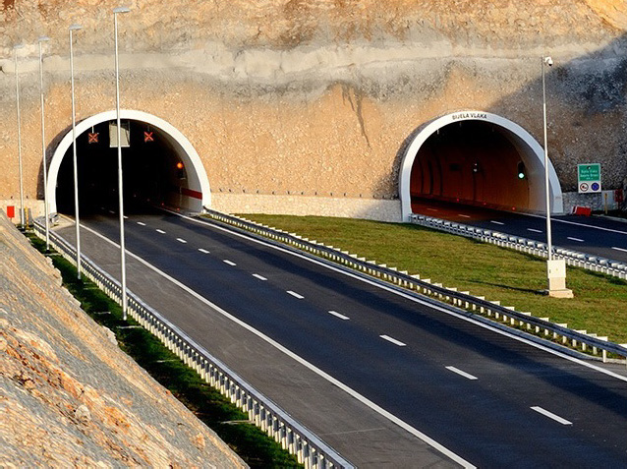

Port

Ship

Highway / Tunnel Railway

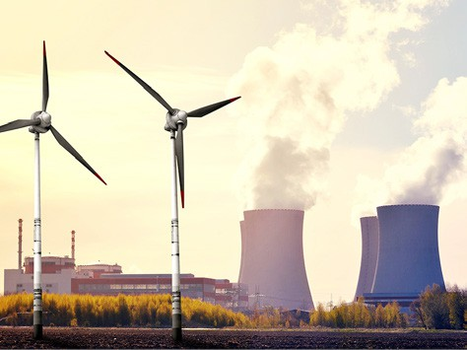 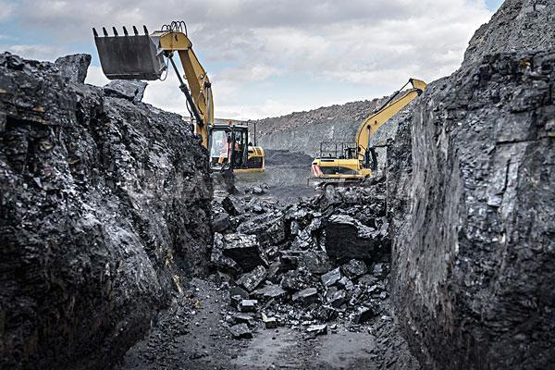 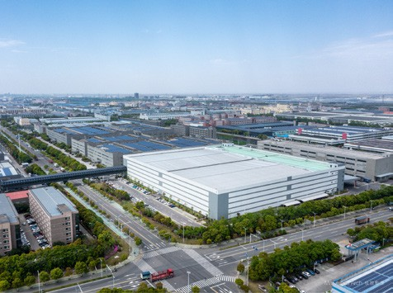 

Generating station

Mining industry

Industrial park

Heavy industry

**DIMENSIONS**

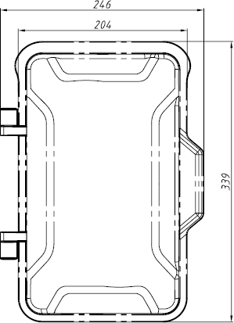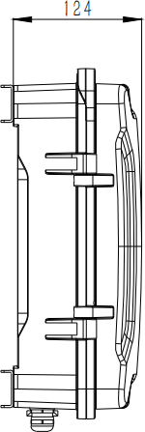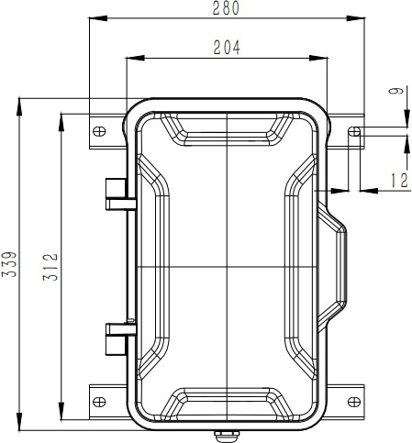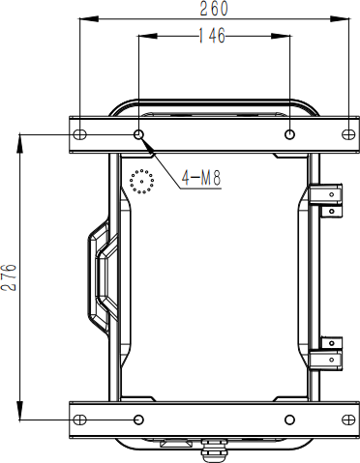

|  |  |
| --- | --- |
| **Package** | |
| Unit size | 246*339*124 (mm) |
| Shipping dimensions | 200*300*440 (mm) |
| Packaging materials | Foam padding, carton |
| Weight | Gross weight: 7 kg / Net weight: 6 kg |



**Add:** 6/F, A1, Xingyi industrial city, Baishixia Est., Fuyong, Bao'an, Shenzhen, China

**Email:** [sales@jrteck.com](mailto:sales@jrteck.com)

**Tel:** +86 - 755 - 27322952

**Web:** [www.jrteck.com](http://www.jrteck.com/)